1. Write a c program to find even or odd?

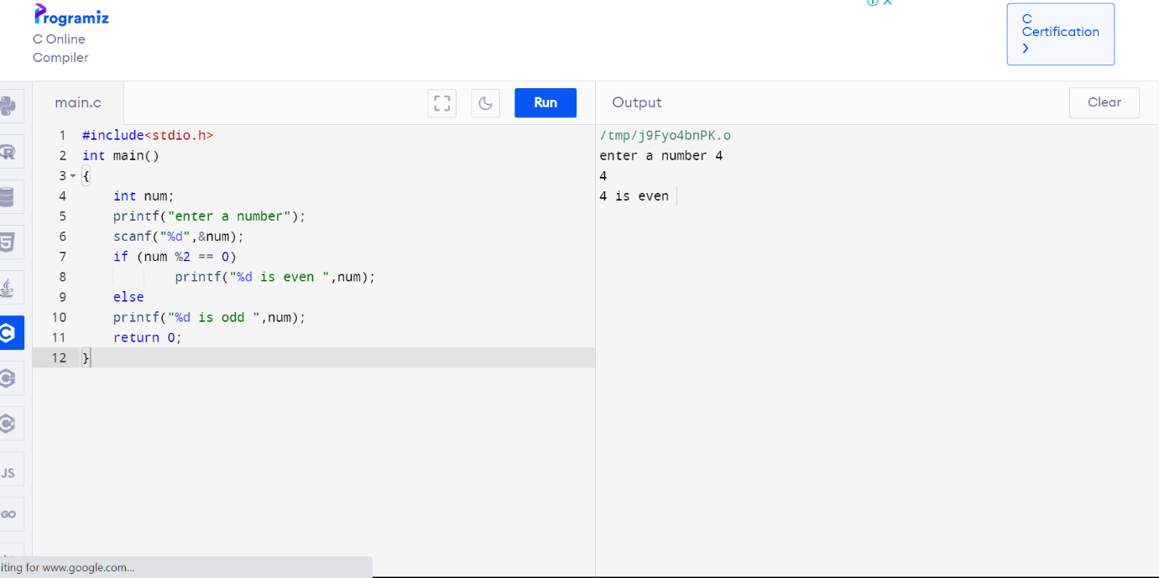

1. C program to find sum of n numbers?

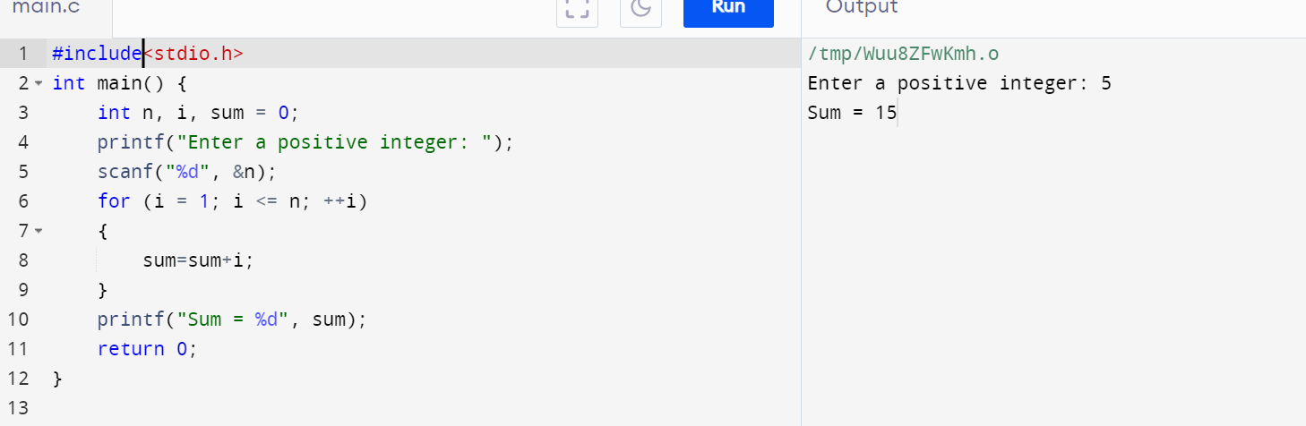

3.C program to find sum of even numbers?

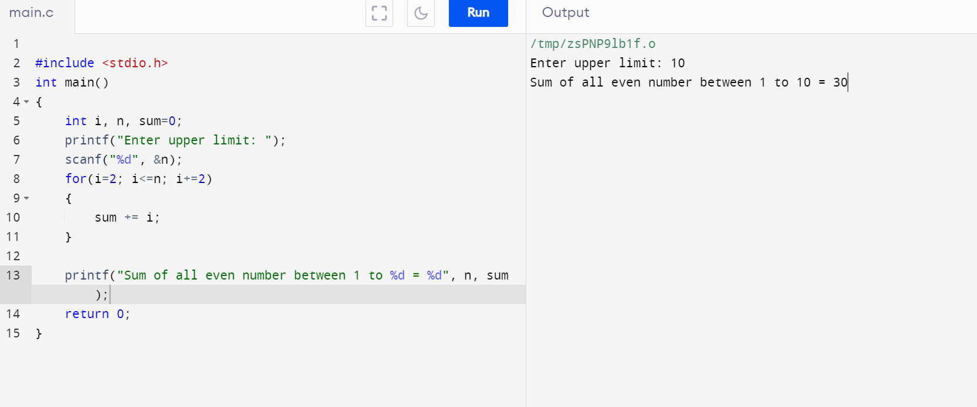

4.C program to find reverse of a number?

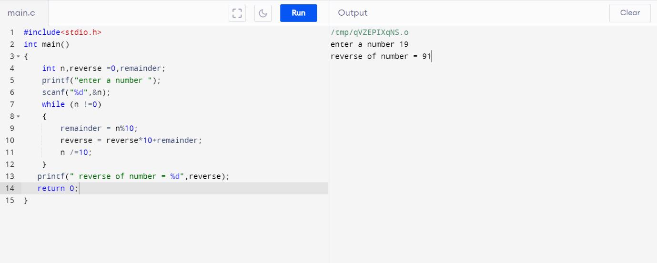

5. write a c program to find palindrome or not?

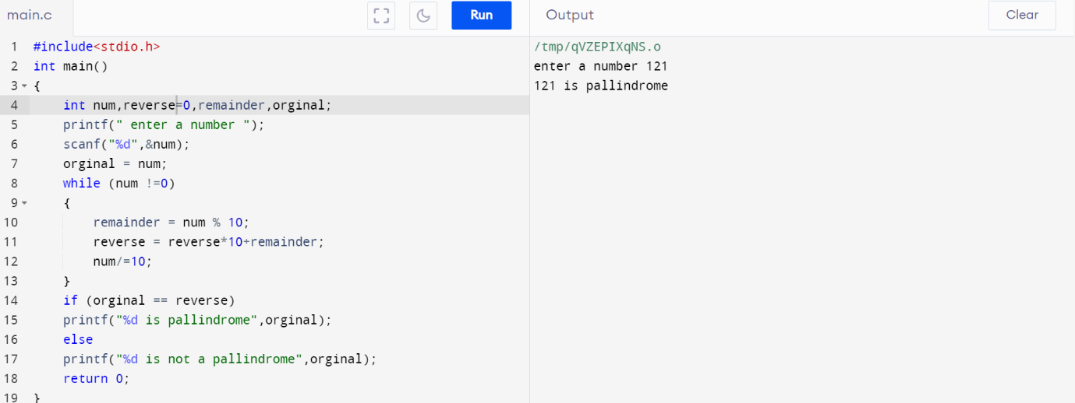

6. write a c program to find Armstrong number or not?

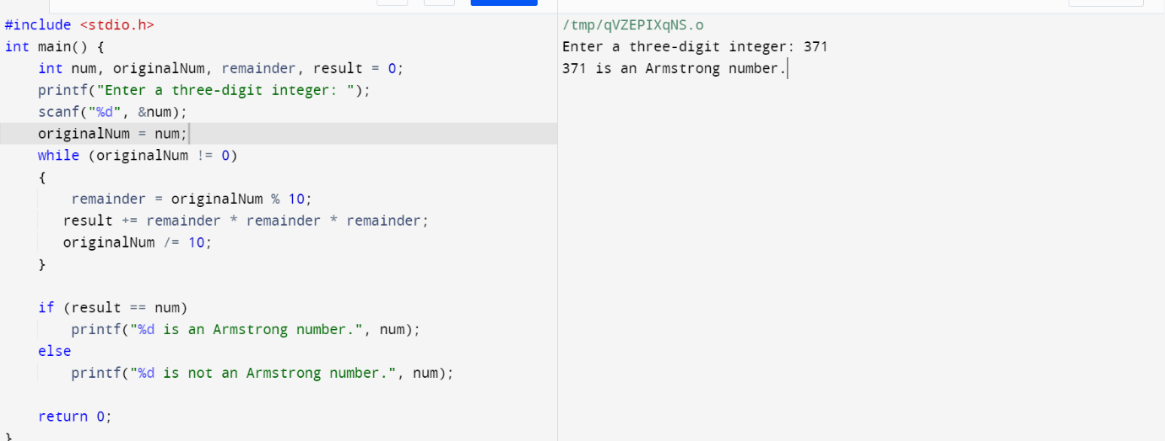

7. c program to find factorial of number without recursion?

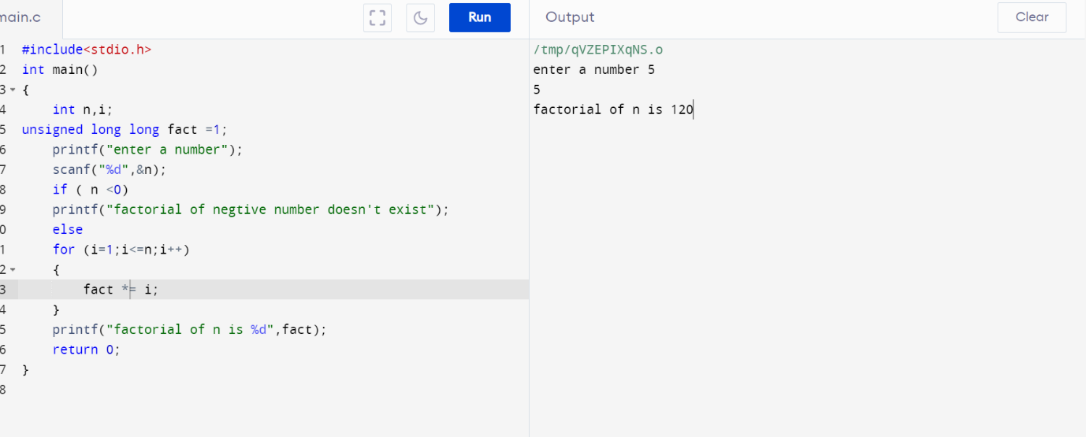

8. c program to find factorial of number with recursion?

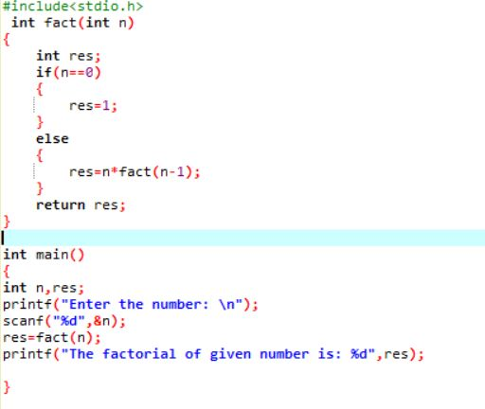

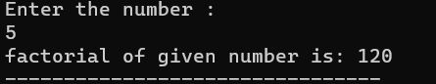

9. write a c program to generate fib

9. write a c program to generate Fibonacci series without recursion?

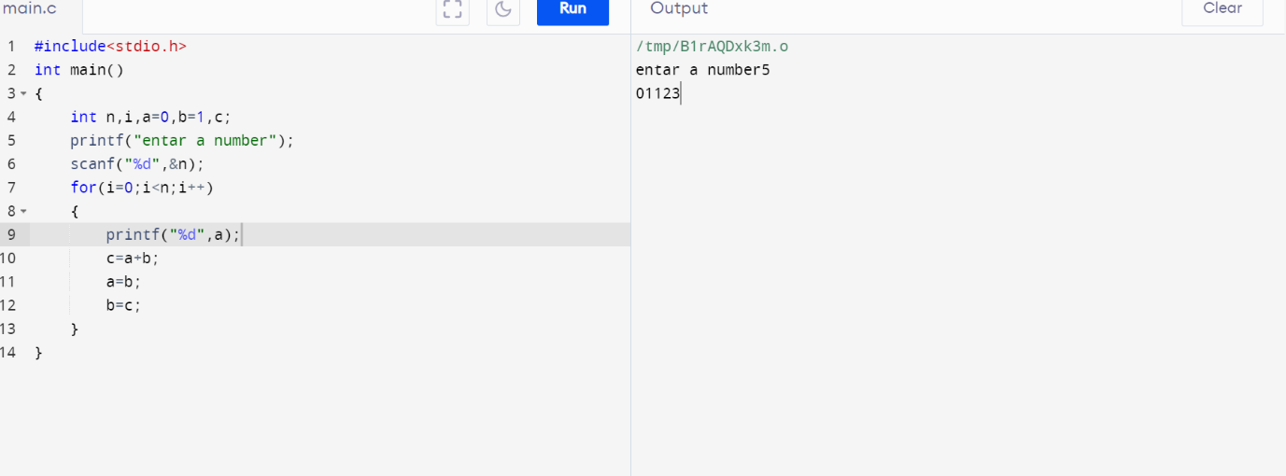

10. write a c program to generate Fibonacci series with recursion?

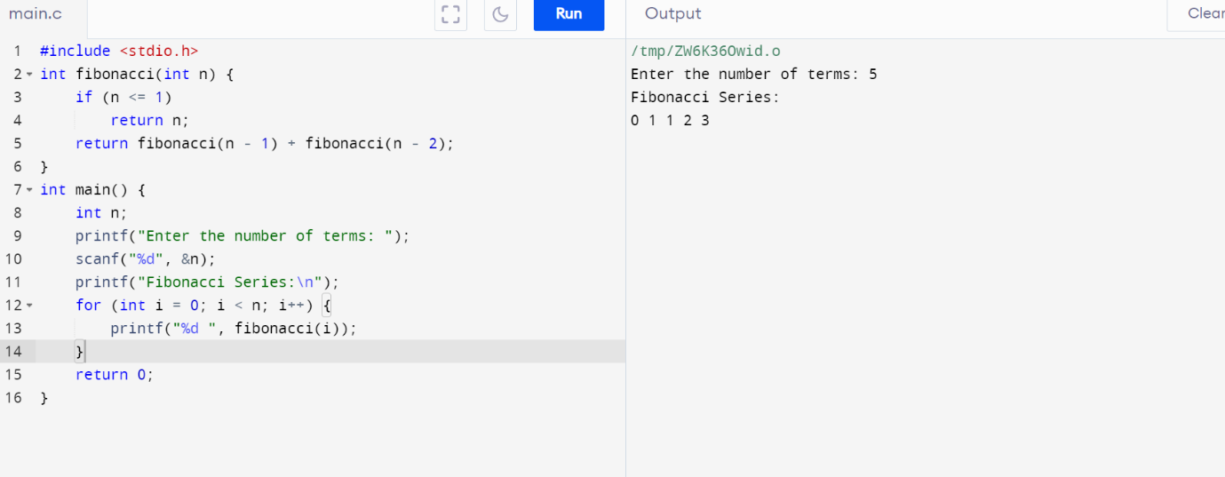

11. c program to search an element in array using linear search?

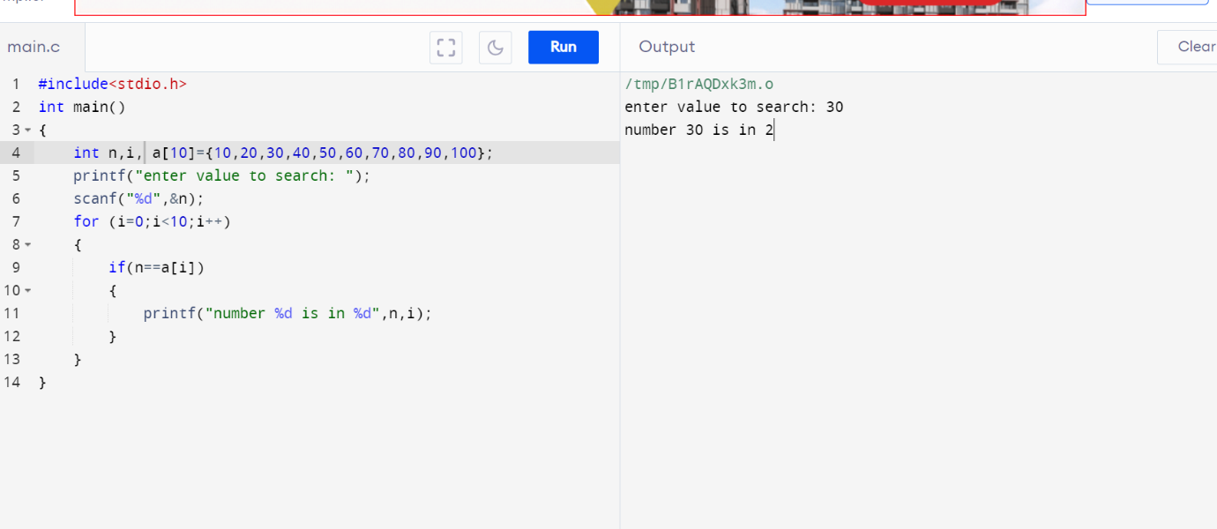

12. c program to search an element in array using binary search?

